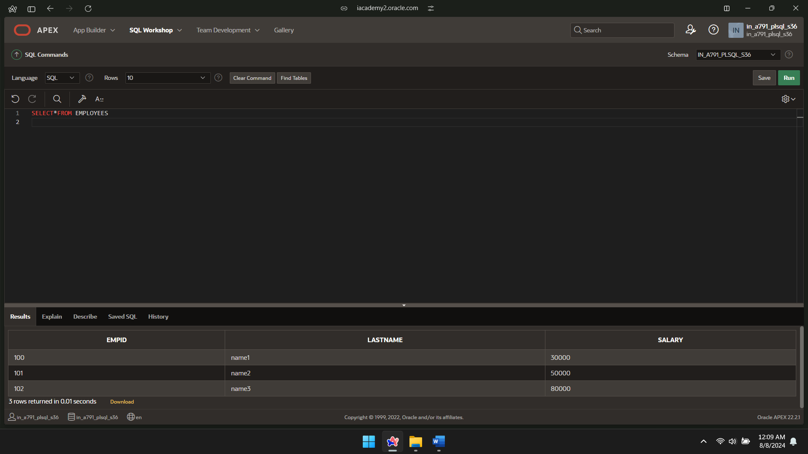

CREATE OR REPLACE PROCEDURE raise_salary

(p_id IN employees.empid%TYPE,

p_percent IN NUMBER)

IS

BEGIN

UPDATE employees

SET salary = salary * (1 + p_percent/100)

WHERE empid= p_id;

END raise_salary;

